Parameters: used for common data:

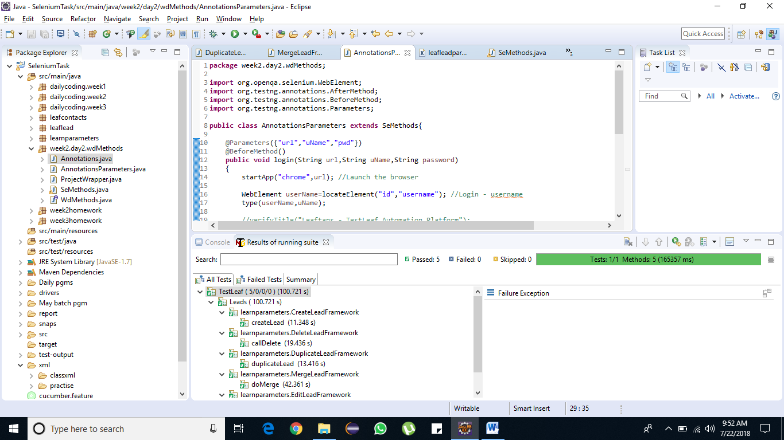

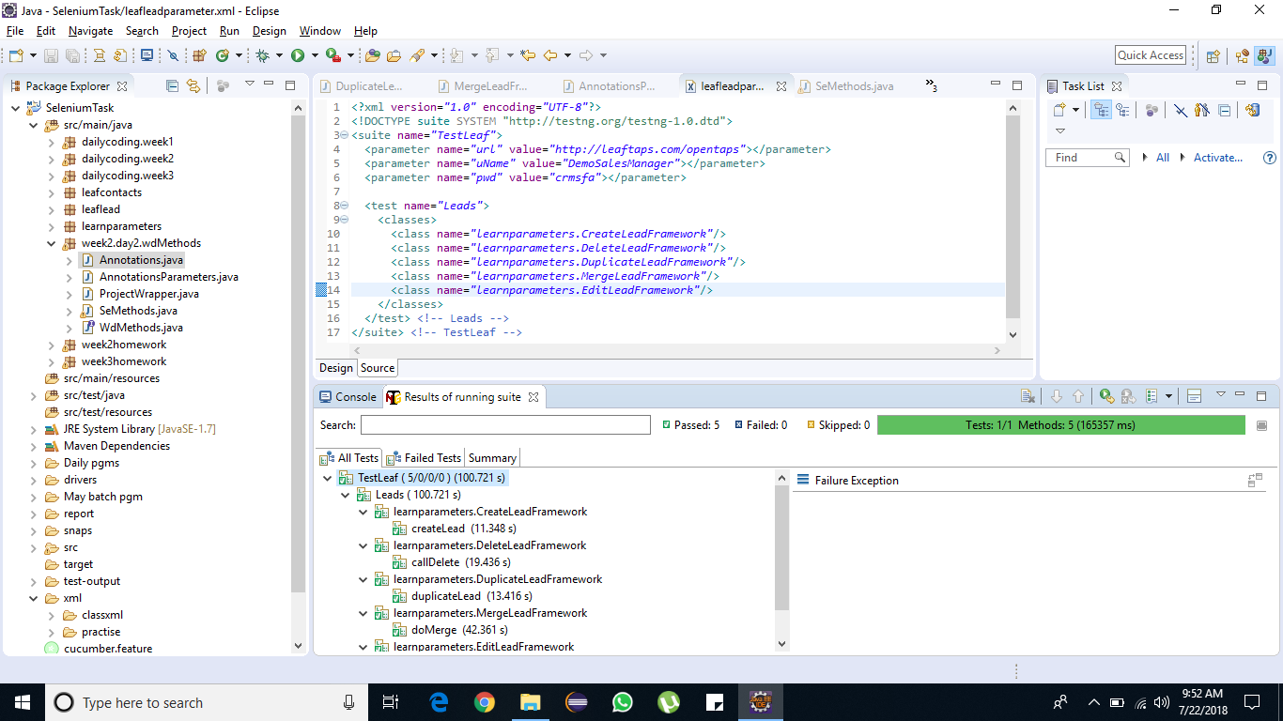

Dataprovider: used only for specific @ Test annotations

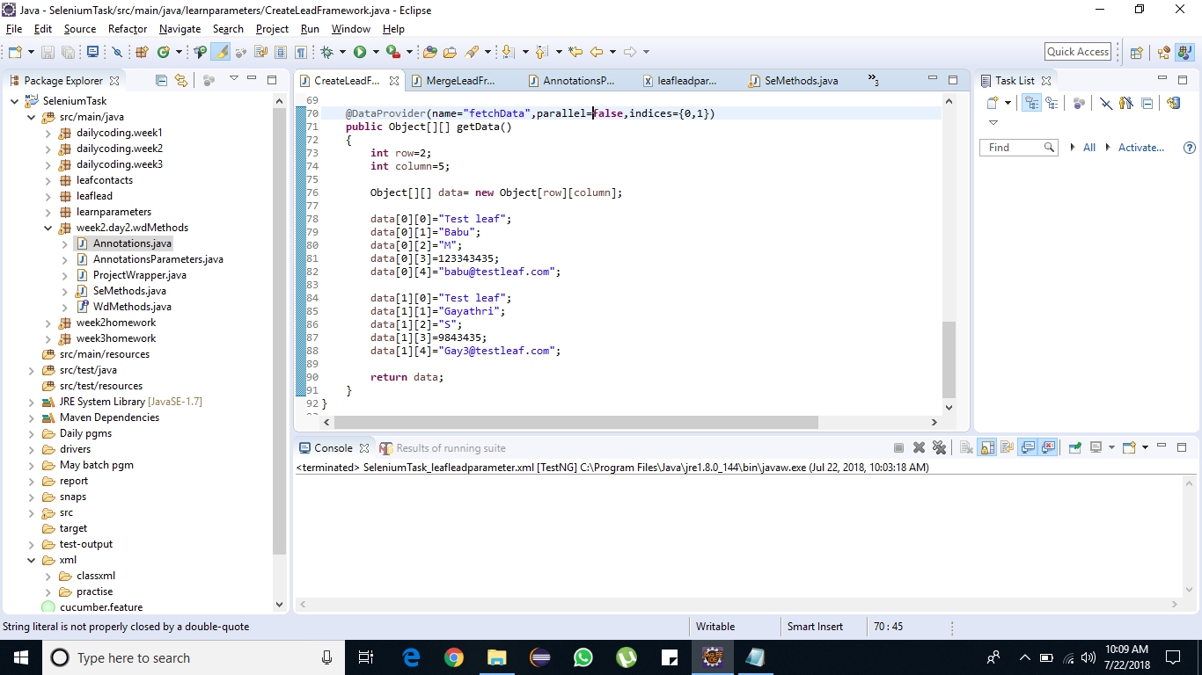

Our @ Test : we were receiving the input values from the @Dataprovider using data provider attribute.

